**Assignment 2 - Simulation and Modeling**

**K20-1052**

**BSE-6B**

**CPU Specifications:**

1. **Core-i5 7th Generation**
2. **16GB RAM**
3. **1TB Hard Drive**
4. **1TB SSD**

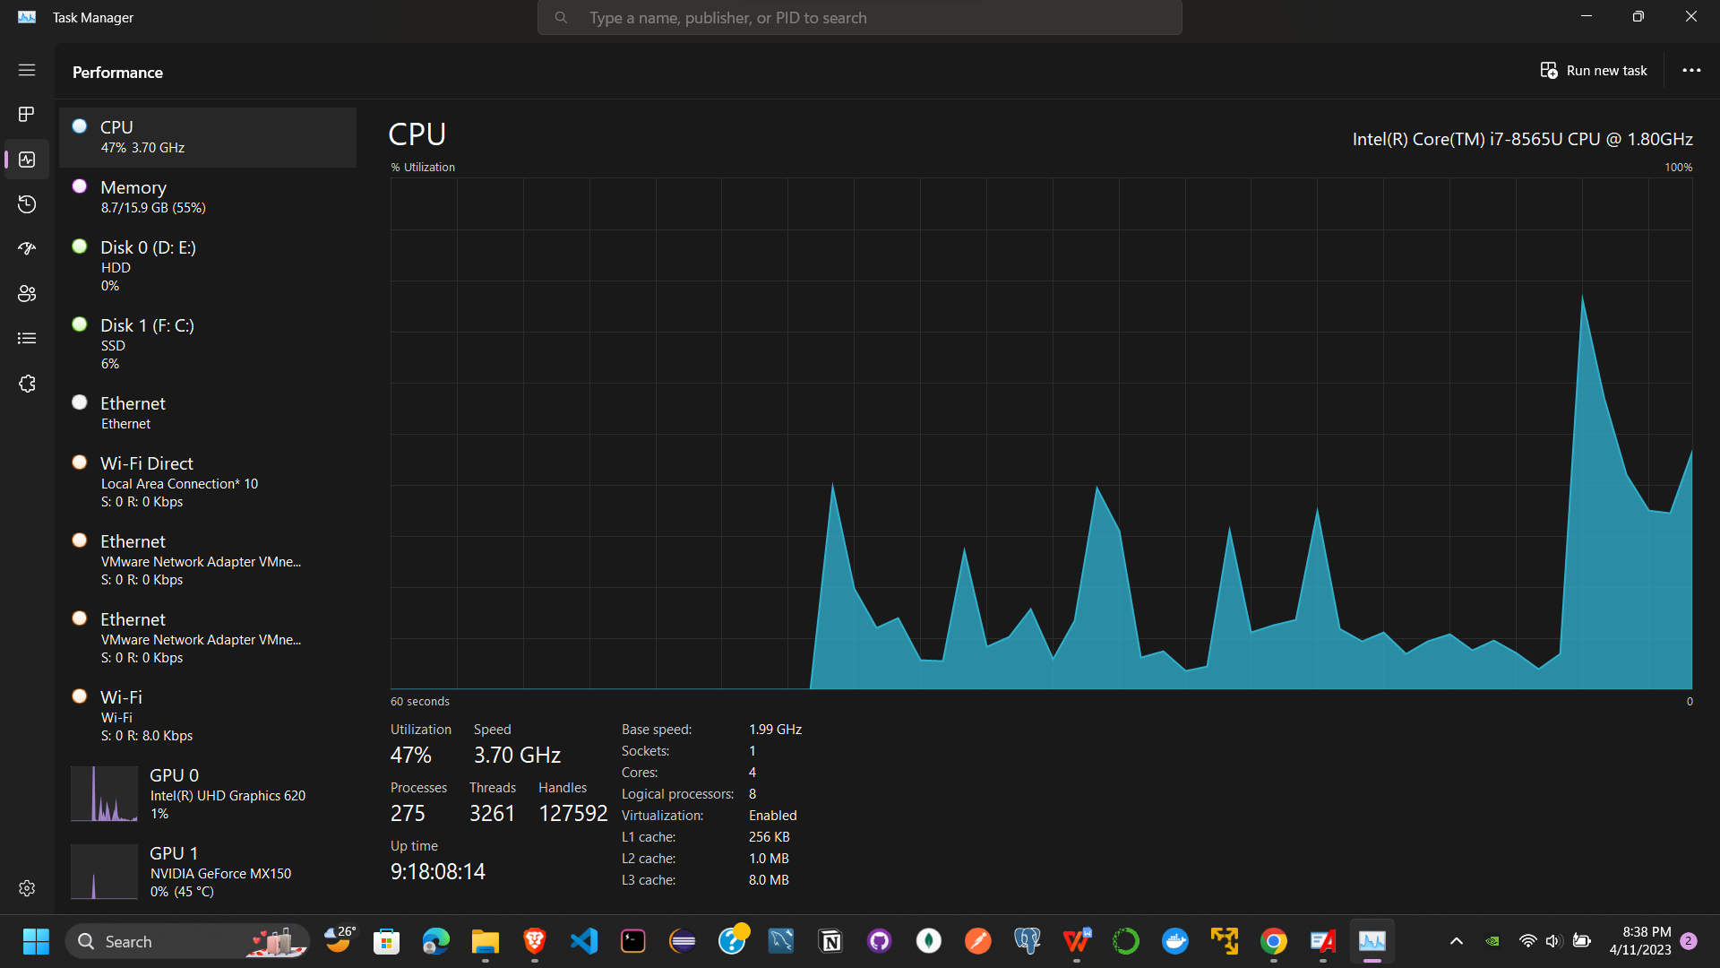

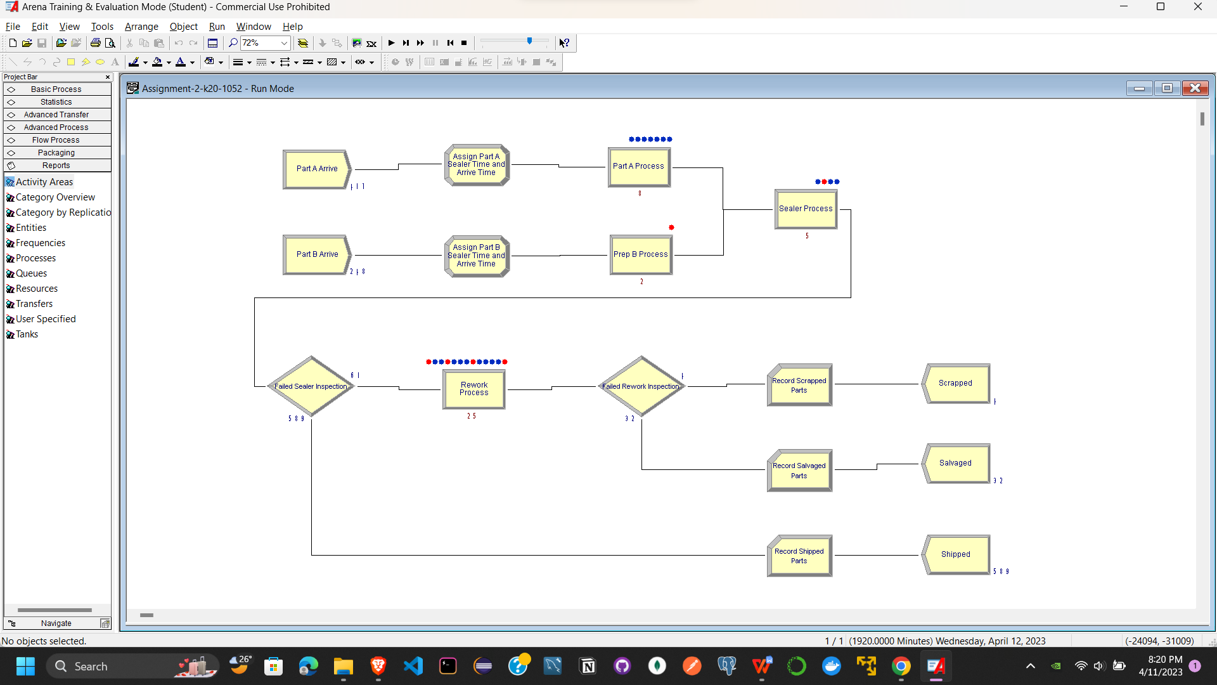

**Part A Arrive**

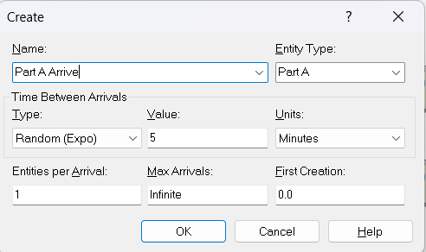

**Part B Arrive**

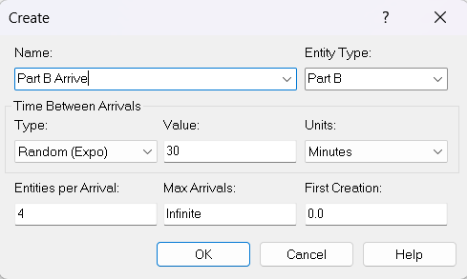

**Assign Part A Sealer Time and Arrive Time**

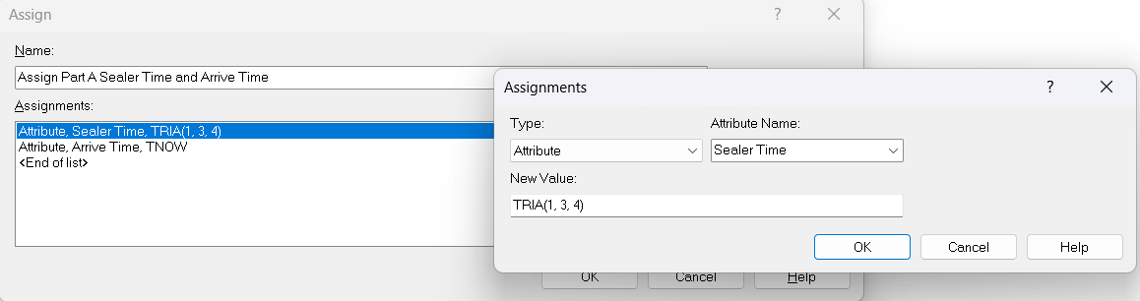

**Assign Part B Sealer Time and Arrive Time**

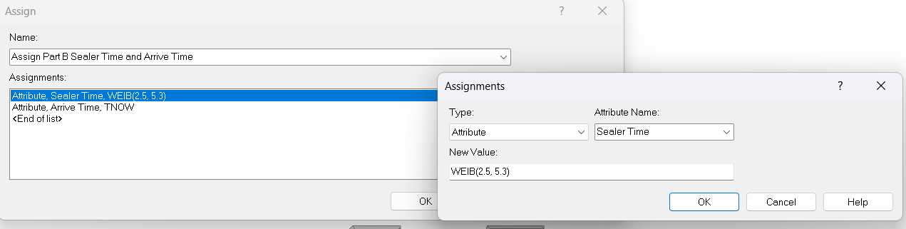

**Part A Process**

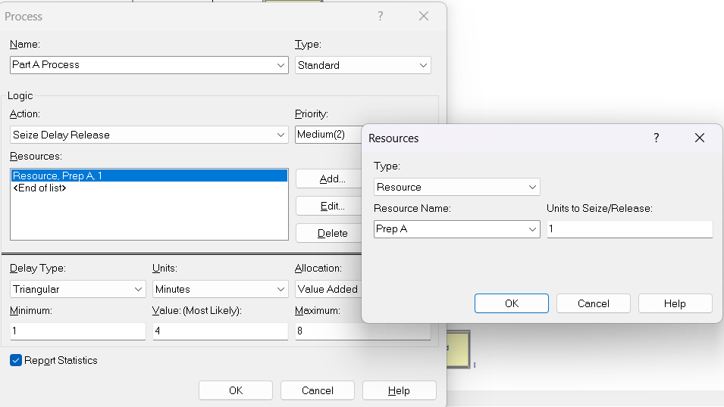

**Part B Process**

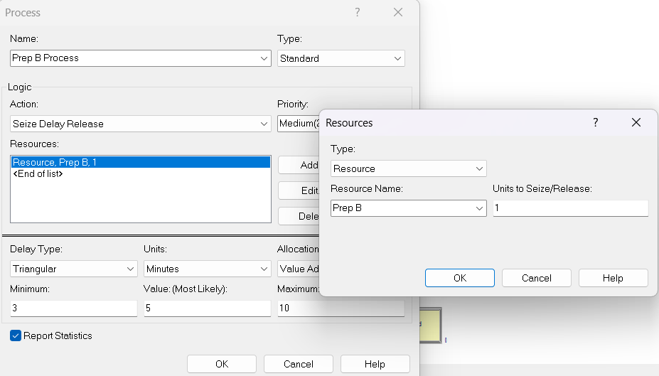

**Sealer Time**

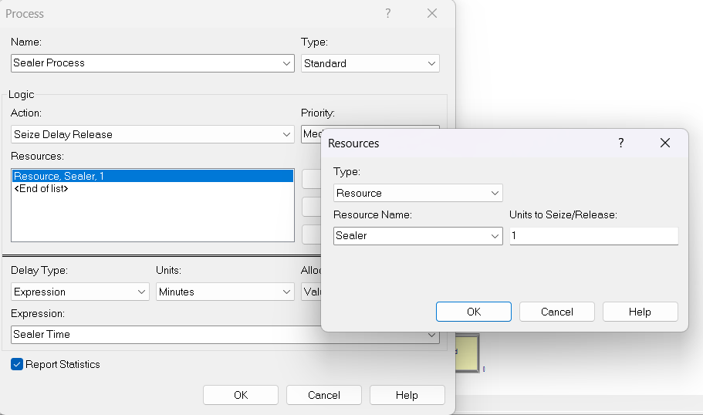

**Failed Sealer Inspection**

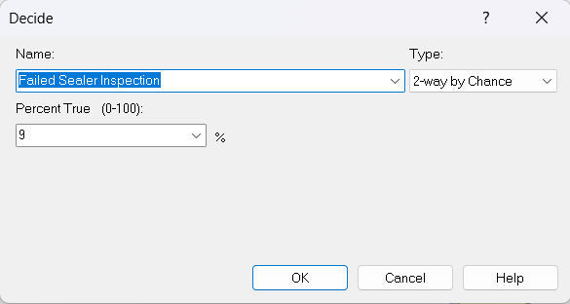

**Rework Process**

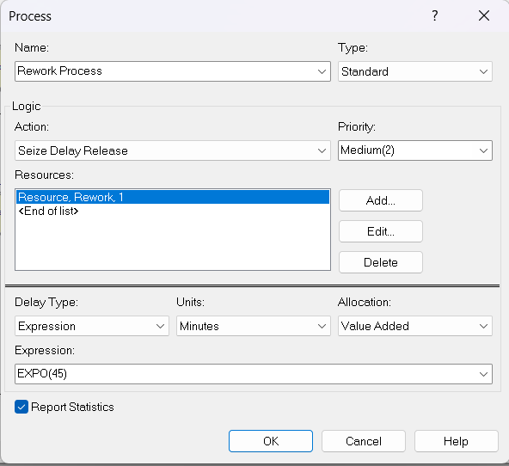

**Failed Rework Inspection**

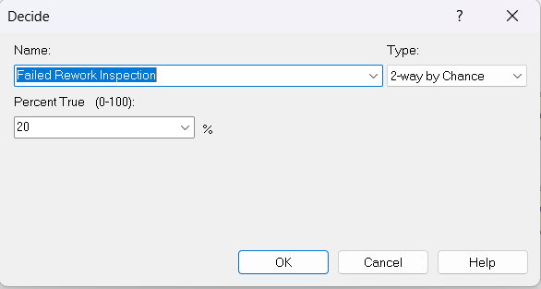

**Record Scrapped Parts**

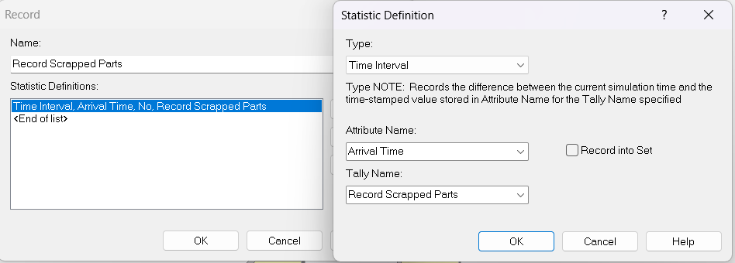

**Record Salvaged Parts**

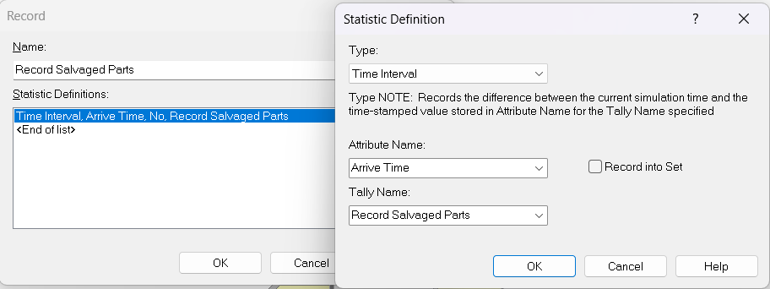

**Running Simulation**

